

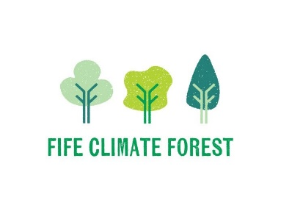

Fife Climate Forest Tree Canopy Survey
Teachers User Guide

Set up
You will need a bit of time indoors with Wi-Fi access to set the survey up on your device before going outside to do the survey. The best way to access the survey is through the free ArcGIS Survey 123 App which you can download from your device’s app store (see below for icon).
Google Play: ArcGIS Survey123 – Apps on Google Play
Apple App Store: ‎ArcGIS Survey123 App - App Store
Microsoft Store: ArcGIS Survey123 - Free download and install on Windows | Microsoft Store
Once you have ArcGIS Survey123 on your device you can open it up and click “Continue without signing in”.
To add the survey to the My Survey123 page, click on the QR code button in the search bar and then scan this QR code to take you to the Fife Climate Forest Tree Canopy Survey.
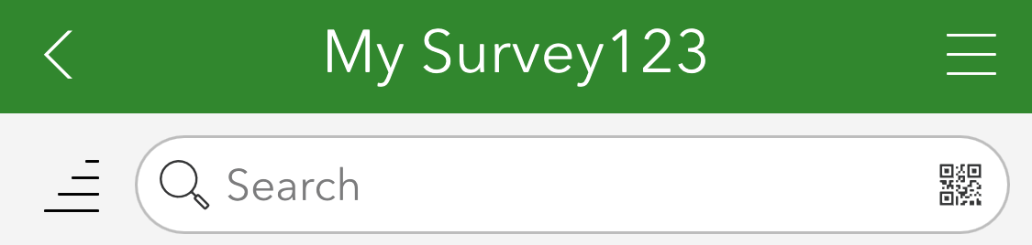


You can also access the survey through the web browser: Fife Tree Canopy Survey

Preparation
You are allowed to survey trees on public land including your school grounds, local greenspace and parks. Please ask permission before surveying any privately owned land including gardens.

Before taking part in the survey, we recommend that you look at leaf identification with learners beforehand so they can identify trees more easily in the field. You may find it useful to take out some resources to help with tree identification. Please use tree id apps with caution as they are not always right.

You will need a tape measure for tree measuring and it is recommended that you practice this with learners so that they are confident to measure the circumference and radius of canopies on different trees. This can all be done in one long lesson of around 1hr 30mins, but for a more in-depth investigation split them into three separate lessons.

Using the survey
Step 1: Find the location of the tree
You will need WiFi to be able to plot your tree location on a map. The first step is to go to the map that appears when you open the survey. You will then be asked if you want to share your location:
- Yes = a point will show where you are
- No = find your area using the search bar and entering your location
Note: If the map doesn’t load, don’t worry, it might be a little slow! If an error appears, try typing in your location and ask an adult for help if needed.
Next, zoom in until you can drop a point. If you see “Zoom to Street Level”, zoom in more.
Tap the map to drop a point where your tree is! A blue marker will appear when you do so, and you can move it to where the tree you are surveying is!
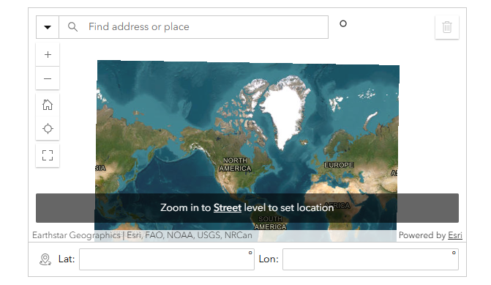
Do you see an orange point in your location?:
- Yes = That is a tree! Please place your marker on it
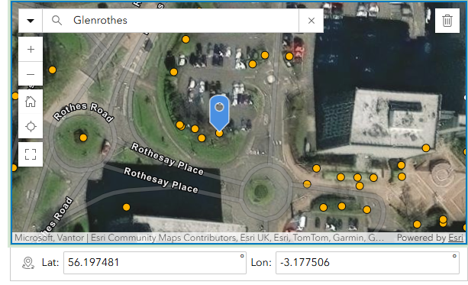
- No = You have found a new tree, you can still place your marker.
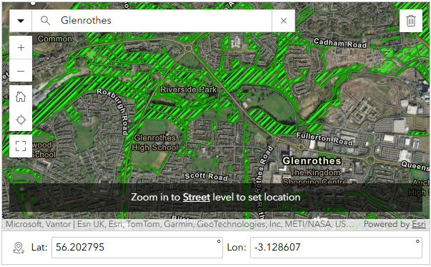
If your tree is in a green shaded areas, you do NOT need to record any of the trees there as we already have data on this woodland area.

Step 2: Is there a tree?
You will then be asked if there is a tree at this location.
If not:
- Was there a tree here before?
- Has it been cut down?
- Is there something that has been mistaken for a tree, like a bush?
Please record what has been mistaken for a tree.
If yes, you are now investigating and surveying a real tree.

Step 3: Have you planted a tree here?
After this, you will then be asked if you have recently planted a tree at the location you have put your marker.
Please select “No” if you have not, and “Yes” if you have.
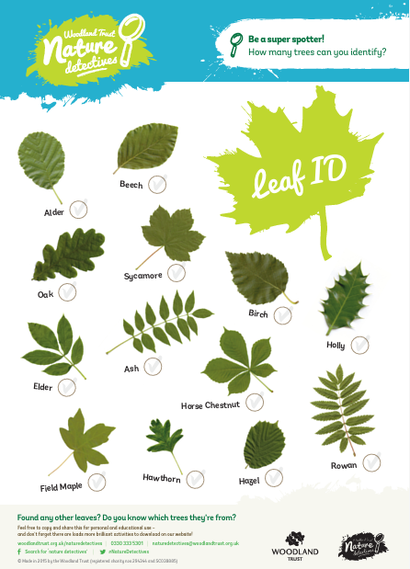
Step 4: Tree identification
Spend a bit of time identifying your tree. There are some great tree identification resources available through The woodland Trust including Treetoolsforschool printable leaf, blossom and flower, fruit and seed spotter sheets and a free Tree ID app.
There is a drop-down list of many different species of trees. This list is in alphabetical order to help find your tree more easily.
This list includes different types of fruit, evergreen (has needles and keeps its green leaves all year round) and broadleaf trees (leaves fall off in autumn).
If you are unsure, scroll to the bottom and select “other”. You can also take a photo.
Step 5: Confidence level
You will then be asked how confident you are with the tree species you have selected.
You will be given a choice of:
- Very sure (80-100%)
- Fairly sure (60-80%)
- Neutral (40-60%)
- Fairly unsure (20-40%)
- Very unsure (0-20%)
This helps us understand how reliable the data is.
Step 6: Write a message to this tree.​
​What does this tree mean to you? ​This is a chance for you to write a small message to your tree which will appear on a public map. This could be a tribute to your tree, a personal remembrance or as simple as something special you have noticed about this tree.
Step 7: Measuring the tree
Measuring your tree is split into two sections: the circumference and the radius of the canopy. Circumference: The circumference is the distance around the trunk of the tree.
- Take your tape measure and go approximately 1.3m up from the ground.
- From that height, take your tape measure and wrap it around the tree's trunk
- Record this in meters and centimeters
If the tree is forked (has multiple stems/ trunks) measure below where the branches flare out. You don’t need to go up to 1.3m from the ground. Instead, wrap your tape measure around the part of the trunk where all the stems connect (before they branch off).
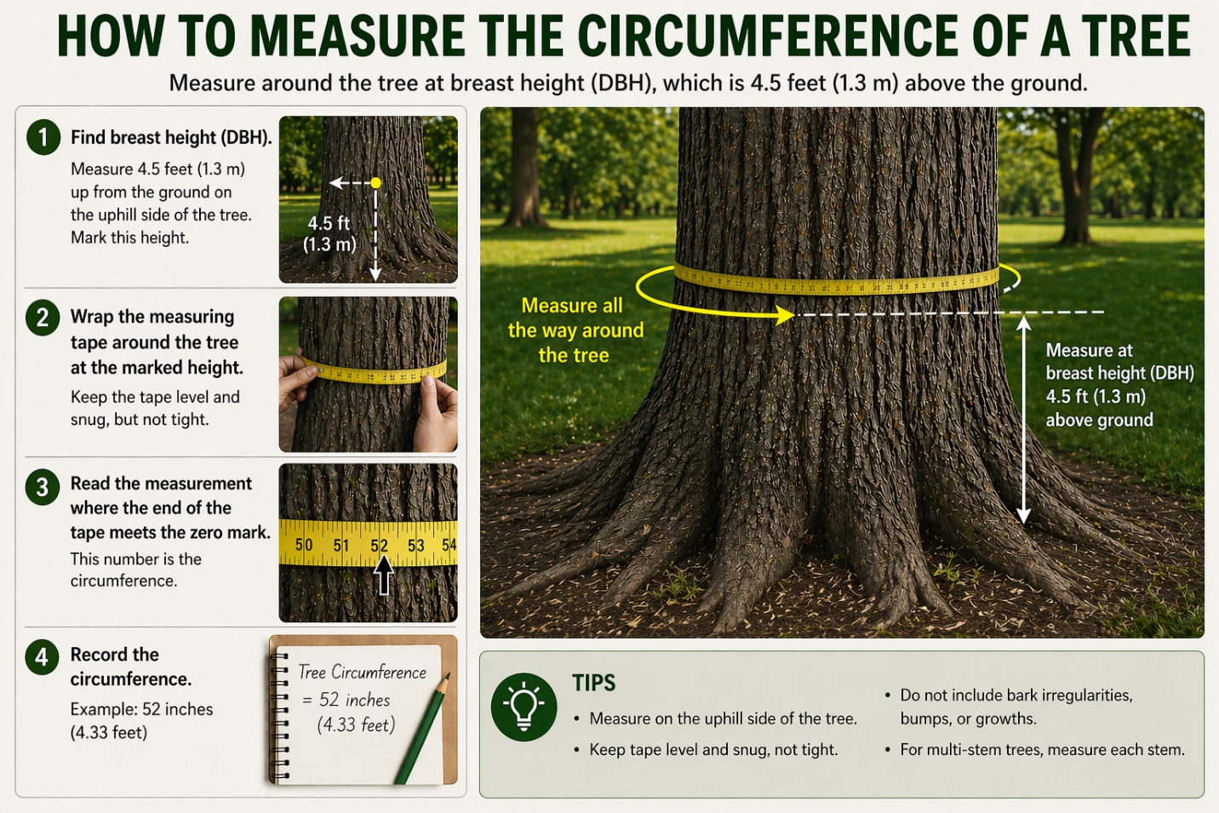
Canopy radius:
The canopy is the spread of the tree's branches overhead. The radius is the distance from the trunk to the outer edge of the branches.
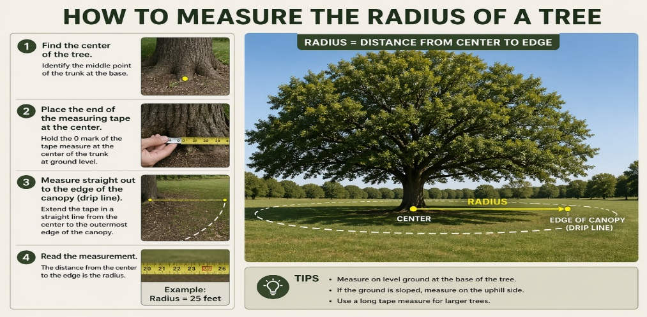

Stand at the base of the trunk and measure in a straight line to where the outermost branches end. If the canopy is uneven, take a few measurements in different directions and record the average.
- Alternatively you can measure how many of your paces you can fit into 2 meters. Pace out the distance to the edge of the branch and divide by 2 to get total number of meters.
- Record in meters and centimeters
Step 8: How healthy does this tree appear?*
Please select the appropriate option of how healthy this tree appears to you.
- Excellent - Tree is growing well and looks extremely healthy; vigorous growth with no signs of pests or diseases
- Good - Tree is growing as expected and showing little or no sign of pests or diseases
- Poor - Tree does not appear to be growing well; you might see signs of poor health and/or pests and disease damage
- Dead - Tree is clearly dead
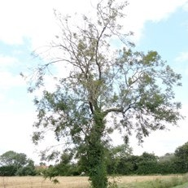
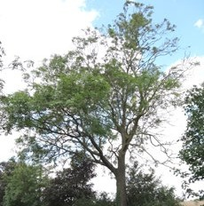
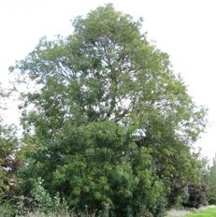
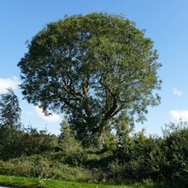

Excellent Good Poor
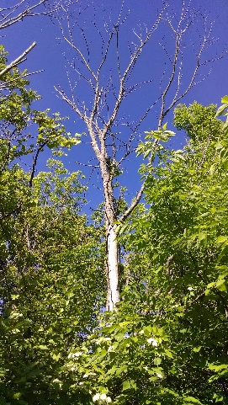
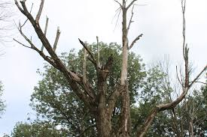
Dead

Step 9: Tree condition (continued)
The next question is whether you feel confident in identifying the health of the tree.
We recommend schools click NO here.
Step 10: Fife Warden
You will then be asked if you are a Fife Tree Warden. This is an adult volunteer initiative run by the Tree Council and Fife Coast & Countryside Trust that supports local champions in planting, caring for, surveying and protecting trees and woodlands.
We recommend schools click NO here.
Step 11: Timestamp and image
Lastly add the date and time you completed the survey.
Add an image of your tree if possible. This would be especially helpful if there is any damage or evidence of pest and diseases.
Thank you for all your help with carrying out this important survey.

