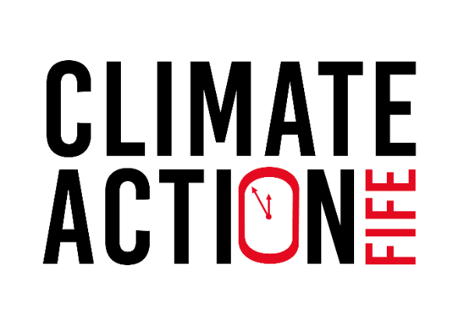

# Small Grants Fund

## What is it?

The Small Grants Fund is open to any Fife community group who wants to work with their community on the climate emergency through events and activities. Groups can apply for a grant of up to £500.

## How does it work?

Applying for funding is simple, and we will get back to you quickly. Successful applicants will receive the funds up front, and the reporting requirements are straightforward.

We have an application deadline, after which the application panel will meet.

The deadline for applications is end of the day on Sunday **22 October 2023**

To apply please email [info@fccan.org.uk](mailto:info@fccan.org.uk) with the following:

* **A completed application form.**
* **A copy of your organisation’s constitution.**

You will hear back from us soon after to let you know if your application was successful.

**Projects should be delivered between 4 December 2023 and 3 March 2024.**

It is a condition of the award to submit a short project report. In the report you will tell us what you spent the grant on, what you delivered and what you learnt. We will also ask for photos from your project.

The deadline for submitting completed project reports is Sunday 17 March.

We will use your report to create a case study of your project and it will appear on the Climate Action Fife and Fife Communities Climate Action Network web pages, social media and in reports for funders.

Please ensure you have permission to share any photographs submitted along with your report.

## Who can apply?

Local community groups or organisations based in, and working in, Fife can apply. Applications will only be accepted from constituted, non-profit-distributing organisations. We are looking for applications from grassroots organisations that are community-led. We cannot fund individuals, so groups will need to have their own bank accounts or partner with organisations that do.

## What can I apply for?

The Small Grants Fund can support any activity that engages your local community in the climate emergency. Your activities should increase knowledge and awareness of the climate emergency. We would also like it to increase skills and confidence to take climate action.

Activities must be aimed at people who are not already engaged in the climate agenda and should get the climate conversation going in your community.

For example, you might want to run climate-themed film showings, ‘climate conversation’ discussion groups, led walks with a climate-change theme or a climate change litter pick. You can read about last year’s Small Grants Fund projects [here](https://www.climateactionfife.org.uk/resources/small-grants-fund-2022-23/).

You can apply for a grant of up to £500 to cover things like staff costs, volunteer expenses, event materials, room hire and marketing. We cannot fund political or religious activities, or the purchase of alcohol. See Appendix 1 for a full list of what we cannot fund.

## Who is behind this?

The Funding is administered by Fife Communities Climate Action Network (FCCAN) as part of our Fife Climate Hub project and in partnership with Climate Action Fife.

FCCAN is a network of community groups in Fife that take action on climate change. We aim to empower and enable communities to create a low carbon future and promote local resilience and well-being. In our network, we share information, resources and knowledge whilst tackling barriers to low carbon living in Fife.

FCCAN deliver the Fife Climate Hub Project. Fife Climate Hub empowers community-led action on the climate crisis. We build capacity of existing community groups working on climate and deliver stronger collaboration between them. We reach beyond the climate engaged to grow a diverse network across Fife. We provide a voice for our members to influence local and national policy. Together we are driving change and strengthening climate resilience in Fife.

Climate Action Fife is a Fife-wide partnership project, bringing together individuals, communities, local government and businesses to tackle the climate emergency and make Fife a greener and fairer place to live. Climate Action Fife is partnership of 12 organisations led by Greener Kirkcaldy. Our community group partners are community-led and rooted in their local areas. Local members, volunteers and participants play an active part in our project. The project is funded by The National Lottery Community Fund’s Climate Action Fund.

## Fife Climate Festival

Fife Climate Festival will run between Saturday 24 February and Sunday 3 March. This will be a celebration of grassroots climate action in Fife. We would love to include your Small Grants projects in our programme, so please consider running your activities during this week.

Small Grants activities running during this period will automatically be included in the programme.

Fife Climate Festival activities will be promoted through FCCAN and Climate Action Fife websites, social media channels and newsletters. This will boost the profile of your event and organisation.

If you would like to include other activities in the programme, please email [info@fccan.org.uk](mailto:info@fccan.org.uk)

# Application Form

The deadline for receipt of applications is **end of the day Sunday 22 October 2023.** Please also send a copy of your organisation’s constitution.

If you have any questions about this form, or the application process, please email [info@fccan.org.uk](mailto:info@fccan.org.uk)

### Your organisation and contact details

|  |  |
| --- | --- |
| Name of group |  |
| Type of group  e.g. charitable trust, CIC, CIO |  |
| Address |  |
| Main contact | Name |
| Telephone number |
| Email address |
| Secondary Contact  (required) | Name |
| Telephone number |
| Email address |
| Organisation website |  |
| Organisation social media links |  |

### Tell us about your organisation. Applicants will only be accepted from constituted, non-profit-distributing organisations, based in Fife. (Max 200 words)

|  |
| --- |
|  |

### Tell us about your community. Where will the project take place? Who is your target audience? (Max 200 words)

|  |
| --- |
|  |

### Tell us about your project. What will you do? Why is it needed? What impact will the project have? (Max 400 words)

|  |
| --- |
|  |

### How will your project or activity get people talking about the climate emergency and climate action? When you deliver your event, how will you communicate the connection between your activity and the climate emergency? (Max 200 words)

|  |
| --- |
|  |

### When will the project be delivered? Tell us your expected start and end dates.

|  |
| --- |
|  |

### What will the project cost? Tell us how you will spend the money you are requesting from the Small Grants Fund. NB. the maximum grant is £500, inclusive of any VAT.

|  |
| --- |
|  |

# Appendix 1: What we cannot fund

In line with our funder’s terms and conditions, we cannot fund:

* statutory activities and activities that replace government funding (for example, we can only fund school activities that happen outside of normal teaching hours)
* loans, endowments or interest
* paying someone else to write your application
* political activities, including lobbying
* activities where a profit will be distributed for private gain
* VAT you can reclaim
* alcohol
* things you’ve spent money on in the past and are looking to claim for now
* items which will only benefit an individual, rather than the wider community
* religious activities (but we can fund religious organisations if their project benefits the wider community and does not include religious content).